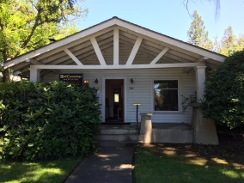 **HULL CUMMINGS PROPERTIES, LLC**

**236 NW “B” Street, Grants Pass, OR 97526 Ph: 541.472.8817 Fax: 541.472.9020**

**REQUEST FOR NAME REMOVAL FROM RENTAL AGREEMENT**

I hereby terminate my tenancy located at:

_____________________________________________________________________

I am willingly turning in my keys (front door, common areas, and mailbox) to Management, and understand that my name will be removed from the Rental Agreement thirty (30) days from the date below. By doing so, I also understand that my occupancy hereby ceases immediately at my own will. Also, that the Security Deposit will be held in the name(s) of the remaining tenants only.

All tenants named on said Rental Agreement must sign below.

____________________________________________ _____________________

Resident Date

____________________________________________ _____________________

Resident Date

____________________________________________ _____________________

Resident Date

____________________________________________ _____________________

Property Manager Date